**A day in the life of a sanitation worker during COVID-19**

**Jason Gonzalez**

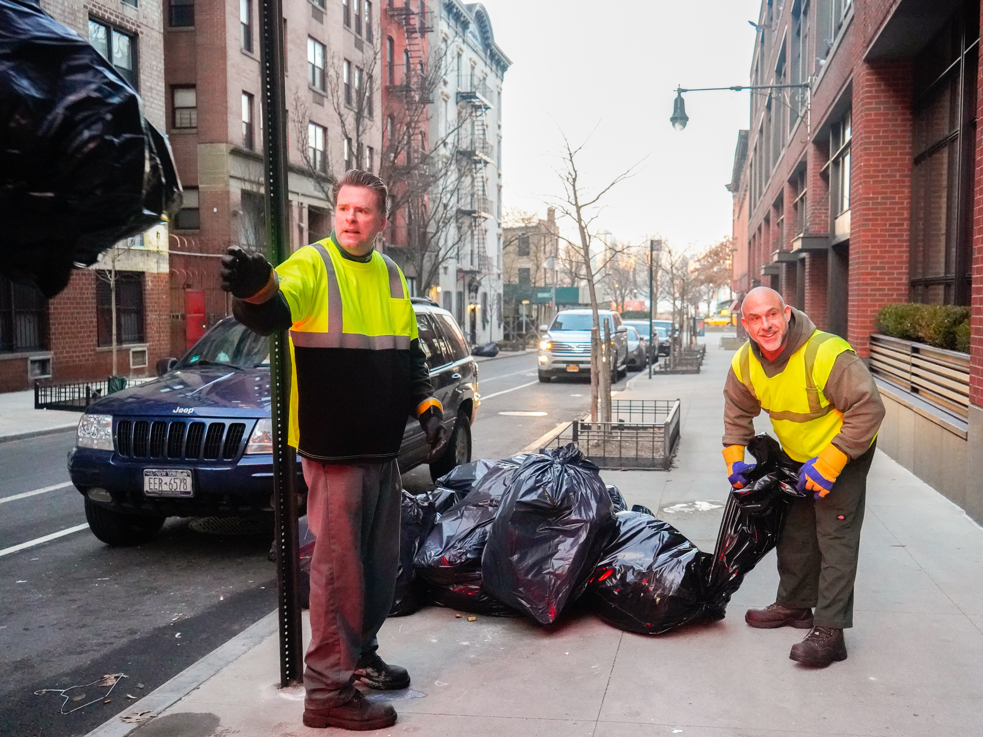

Picture courtesy of Business Insider on Google Images:

Hard at work!

## What is it like to be a sanitation worker during a global health crisis? The staff of the New York City News spent some time with a few of the unsung heroes from the DSNY Bronx 12 Sanitation Garage in the Baychester section of the borough. Bronx 12

Picture courtesy of <https://dsnyfamily.com/bcc/bronx/bx12/>

Bronx Sanitation Garage 12 shown in image:

## This is the garage where sanitation workers meet each morning prior being deployed on their routes that cover the jurisdictions of 10466, 10467, 10469 and 10475.

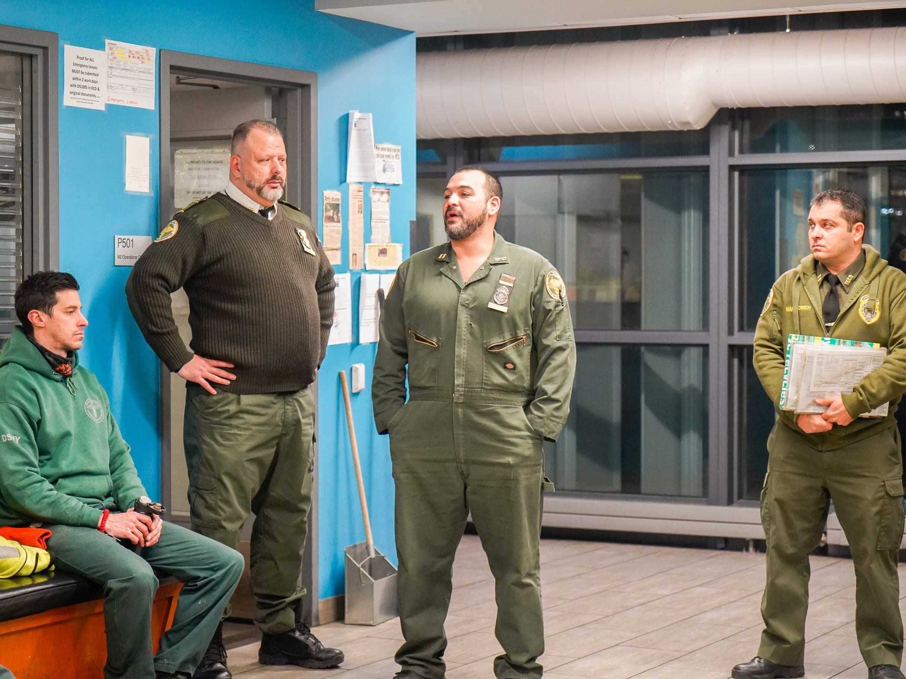

Picture courtesy of Business Insider on Google Images:

Our unsung heroes congregating prior to the start of their shift.

When we think of the term "essential workers," more often than not, for whatever reason sanitation workers are kept off the list. Since the beginning of the pandemic, sanitation workers in the "Big Apple" have become a part of the frontline workforce that keeps the city running. However, as we approach the autumnal equinox, a second wave of the novel coronavirus is expected to hit. But much worse, due to the fact that COVID-19 will combine strength with the flu.

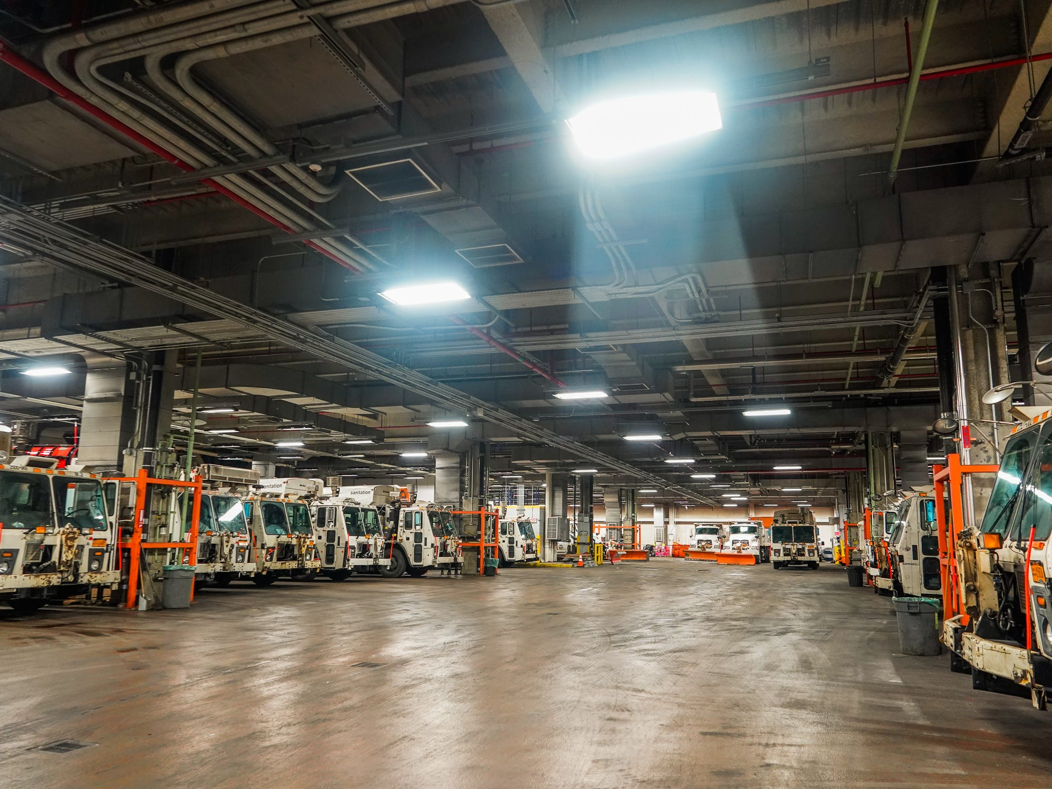

Picture courtesy of Business Insider on Google Images:

A bevy of trucks parked inside of the garage.

"You can go your whole life without ever calling a firefighter or a police officer, but you can't go more than a couple of days without having a sanitation worker in your life," said Belinda Mager, the Communications Director of the New York Department of Sanitation. "They visit your block at least a couple of days a week and you may not even know it! But you'd know if they weren't there!”

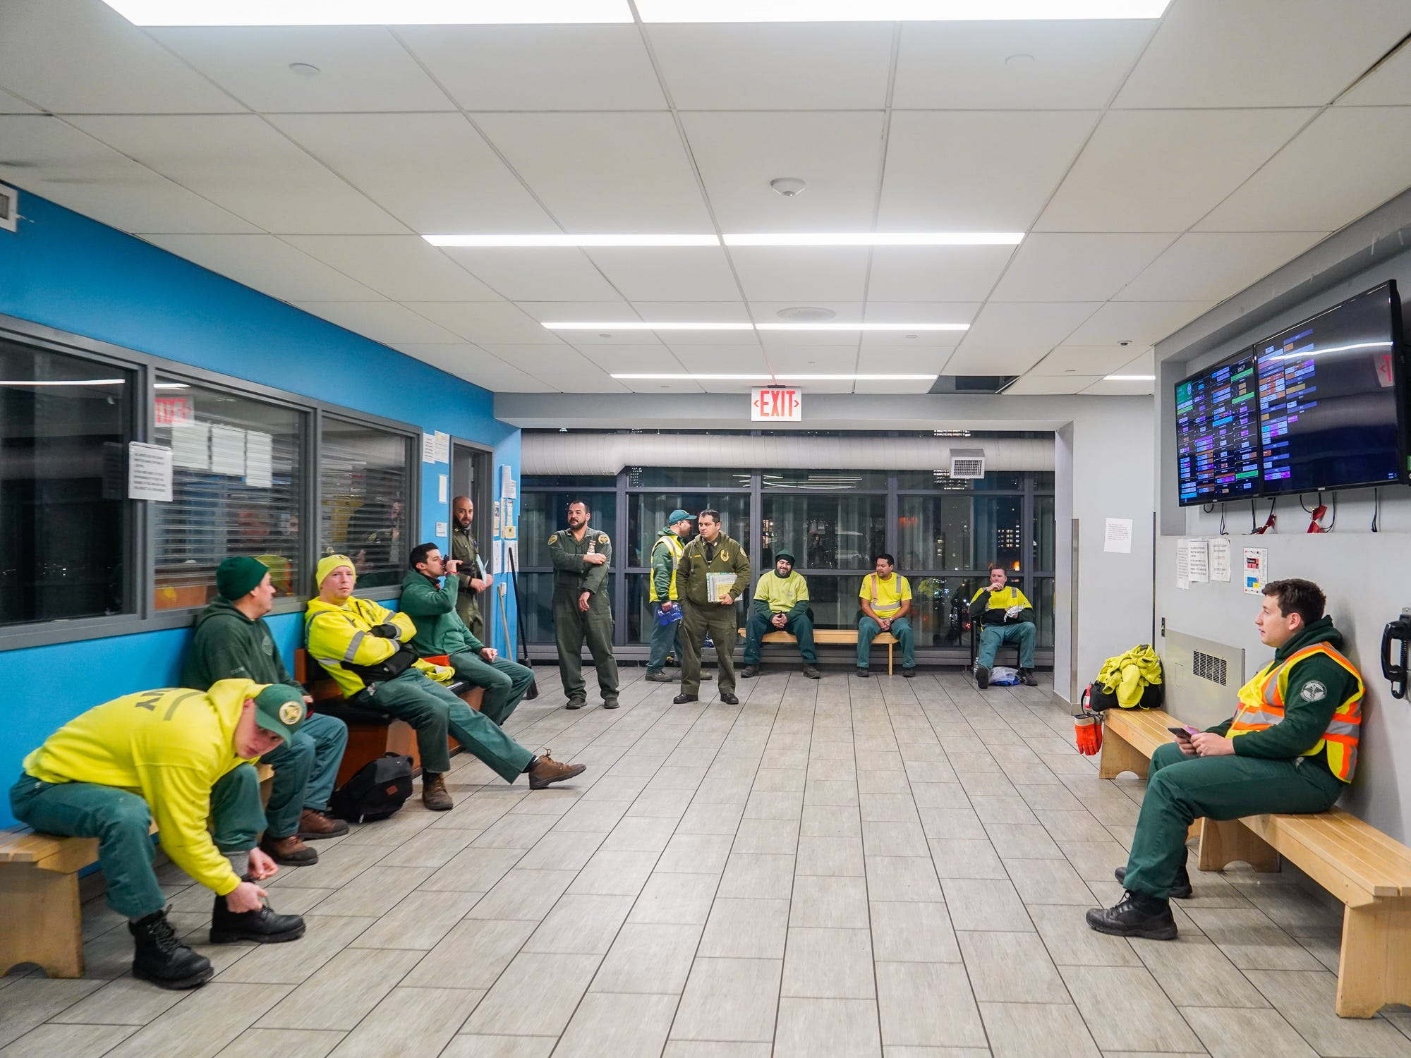

Picture courtesy of Business Insider on Google Images:  
Sanitation workers patiently waiting for their assignment so that they can begin their day.

## Sanitation workers provide services that ensure the comfort and cleanliness of the general public. However, there were some astonishing numbers disclosed by DSNY personnel suggesting that by the end of June, of the approximately 10,000 sanitation workers employed by the DSNY across the five municipalities, 628 of them have tested positive for COVID-19. Of the 628 infected, seven have died. Queens sanitation worker Raymond Copeland was the city’s first casualty resulting from coronavirus-related complications.

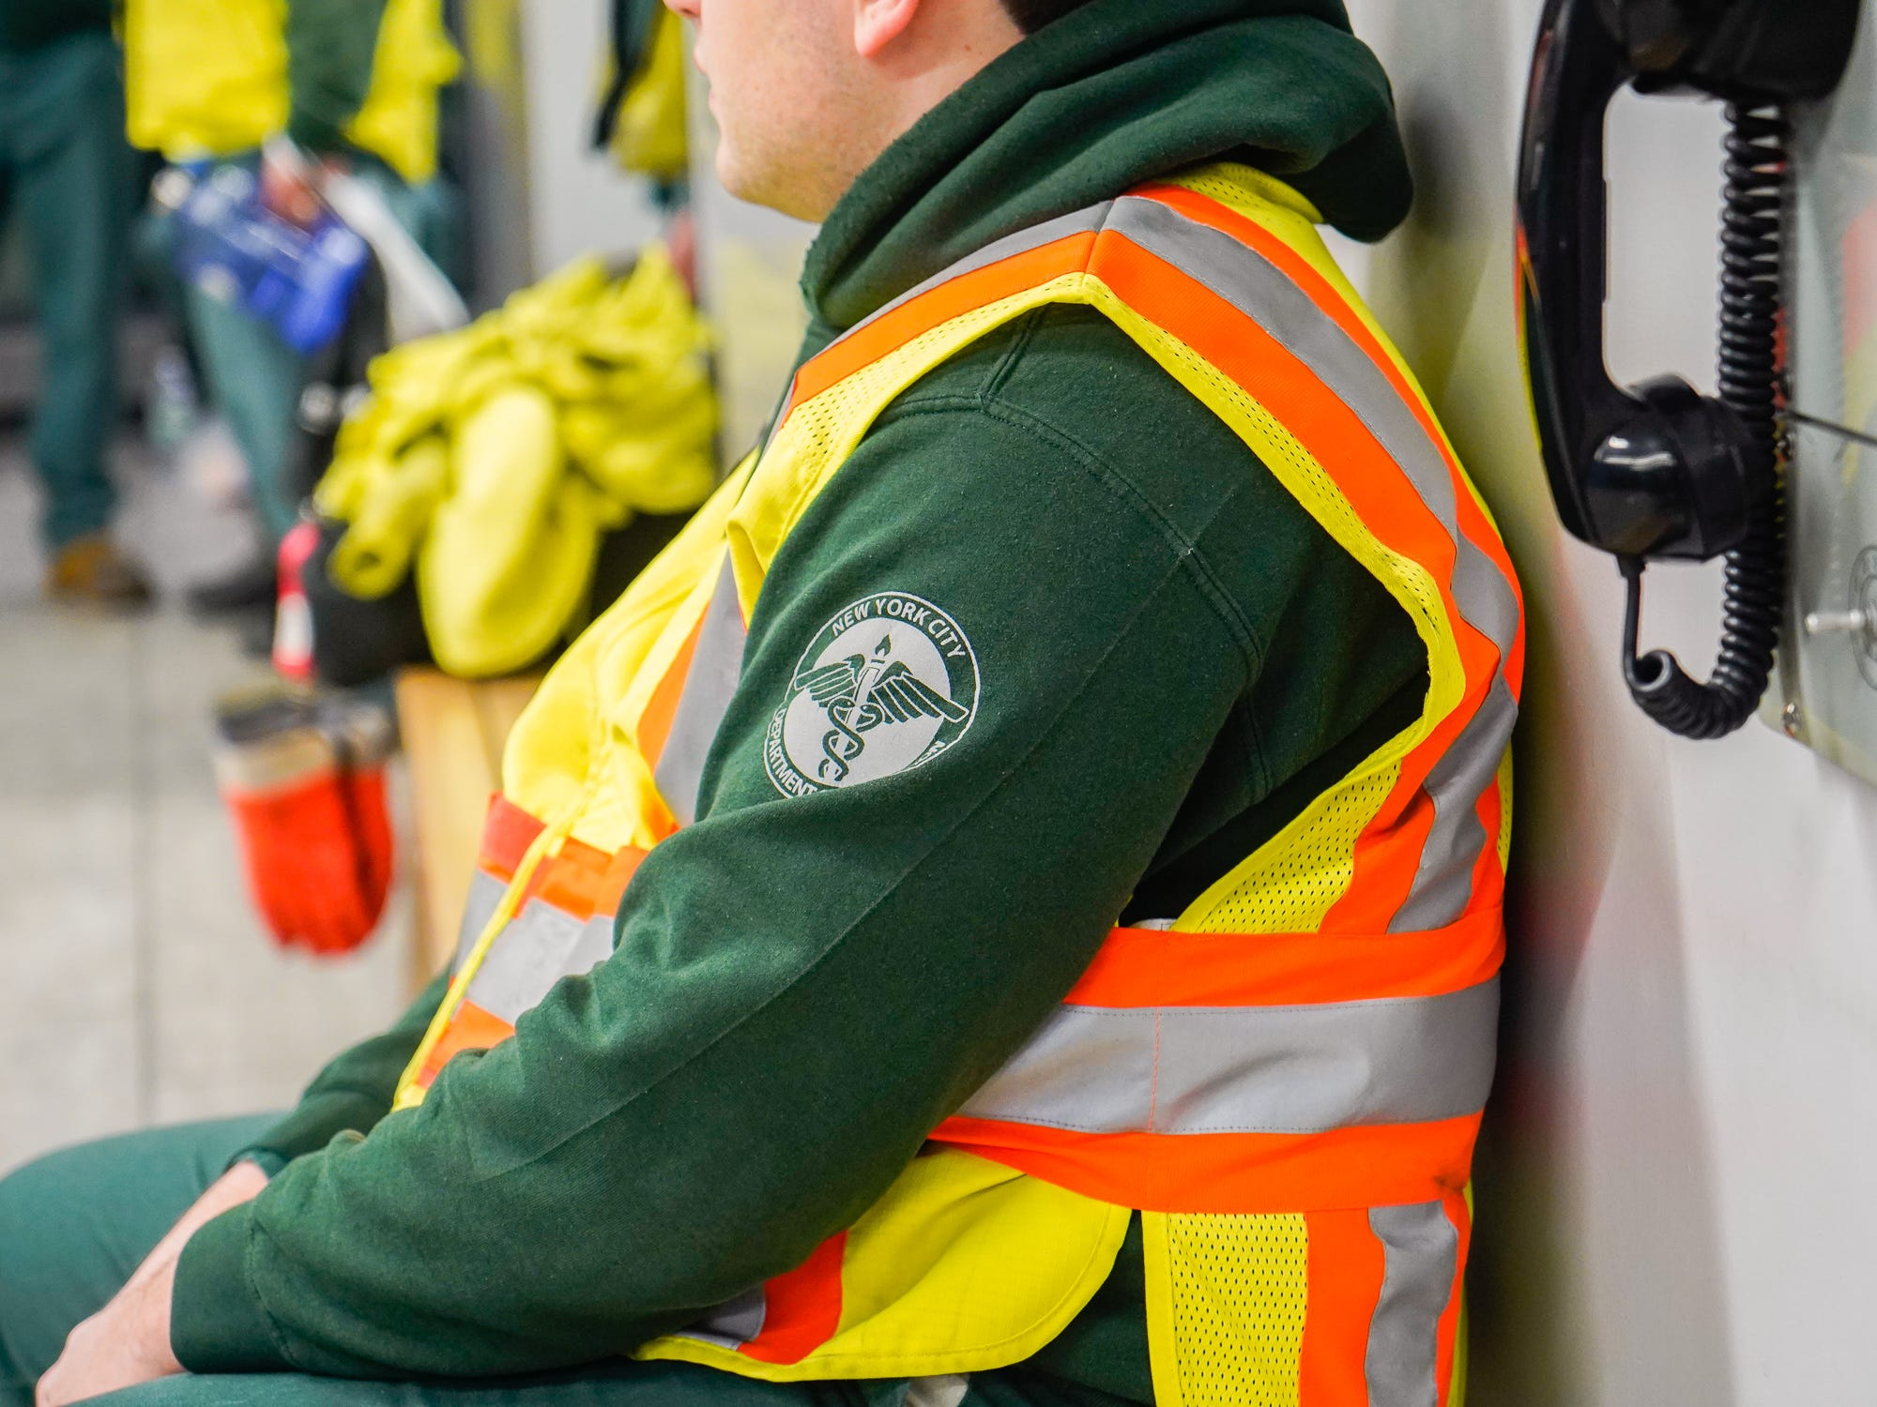

Picture courtesy of Business Insider on Google Images:

Sanitation participating in his morning roll call

All sanitation workers must start their shifts one hour early. Therefore, if your day starts at 6 am, the staff is now required to report to the garage at five. This will limit any interaction with the public because few people will be outside. Garages and trucks are also being disinfected with aerosol sprays and other cleaners on a regular basis. Lastly workers are required to wear masks and gloves while on the clock.

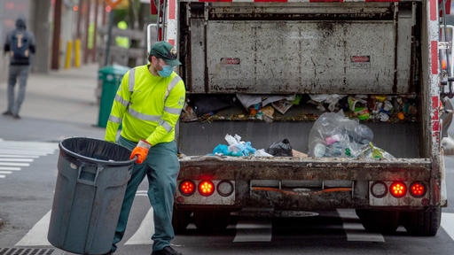

Picture courtesy of newsbreak.com

A sanitation worker protecting himself and others by wearing a mask and gloves

## "With the pandemic happening, I feel a responsibility to come and help the rest of the city," said Diego Dallas a 10-year vet of the department. "We are lifeguards, we are essential workers and we have to be here to help everyone else."

## 

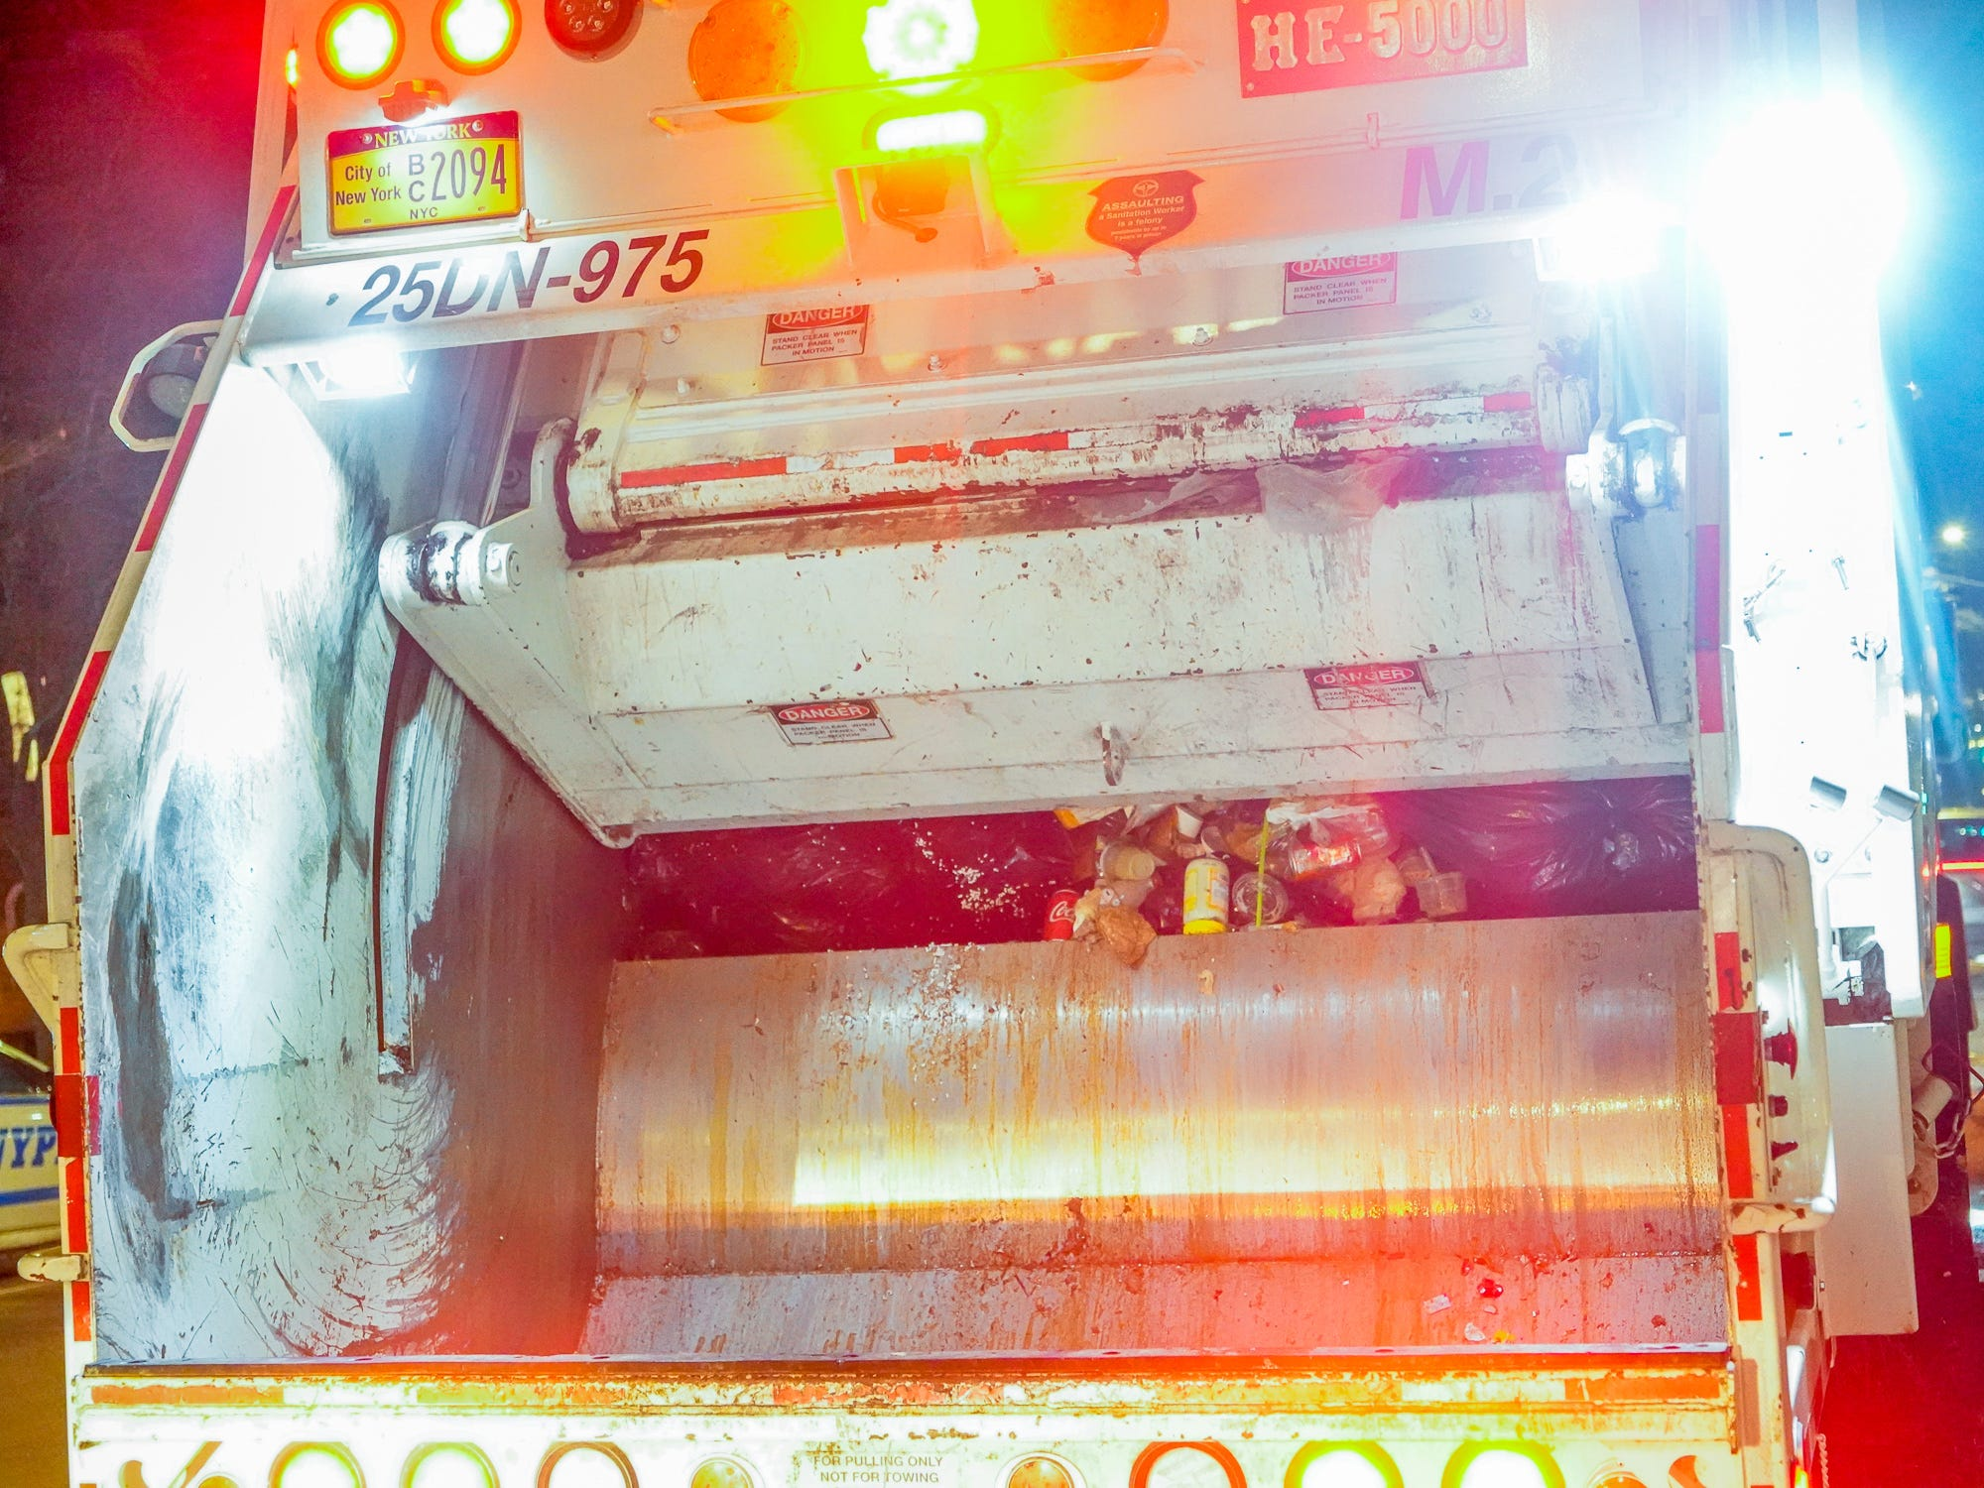

Picture courtesy of the Daily News on Google Images:

According to multiple sources in the garage, based on keeping a tracker, they confirmed that litter and other waste products in residential areas has increased by 40%. Sanitation workers in the five boroughs are acclimating to unusually high levels of waste, as COVID-19 keeps many of the non-essential workers at home.

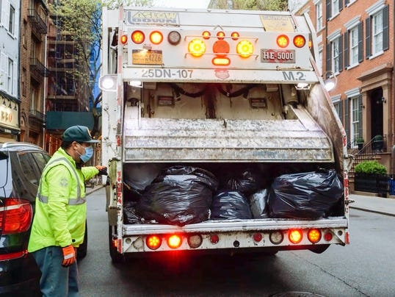  
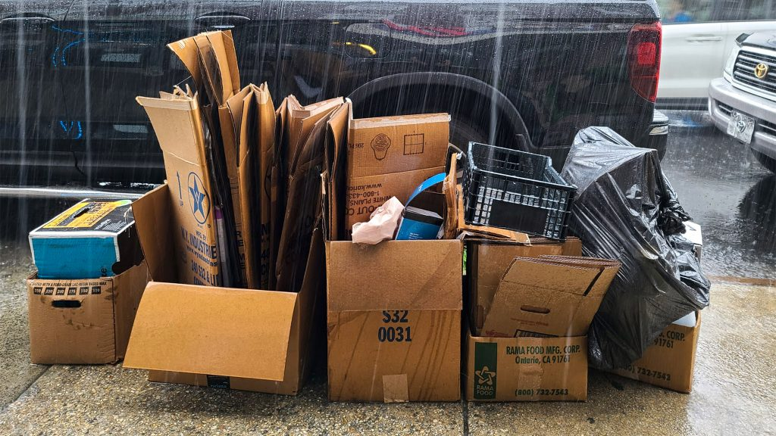

Pictures courtesy of Google Images:

A lot more trash than the norm. A lot more cardboard than the usual.

## "There's way more cardboard," he stressed to the staff of New York City News. "There are a lot of boxes from Amazon, FreshDirect too, a lot of Instacart and oh how can I forget, FedEx."